**Exp1_Aim: To explore basics of python like data types (strings, list, array, dictionaries, set, tuples) and control statements.**

### THEORY:

1. List the different data types in python. Explain how each can be defined.

Ans:

**Strings:**

It comes under sequence type. In Python, Strings are array of bytes representing Unicode characters. A string is a collection of one or more characters put in a single quote, double quote or triple quote. In python there are no characters data type, a character is a string of length one. It is represented by str class.

**Lists:**

Lists are just like arrays, declared in other languages which is an ordered collection of data. It is very flexible as the items in a list do not need to be of the same type. Lists in python are created by just placing inside the square brackets[].

**Dictionaries:**

Dictionary in python is an unordered collection of data values, used to store data values like a map, which unlike other data types that hold only a single value element. Dictionary holds key:value pair. Key-Value is provided in the dictionary to make it more optimized. Each key-value pair is separated using colon(:) whereas each key is separated by a comma(,).

**Sets:**

In Python, Set can be an unordered collection of data types that is iterable, mutable and has no duplicate elements. The order of elements in a set is undefined though it may consist of various elements.

**Tuples:**

Just like list, tuple is also an ordered collection of python objects. The only difference between tuple and list is that tuples are immutable i.e tuples cannot be modified after it is created. It is represented by tuple class.

1. Differentiate in between them

Ans:

|  |  |  |  |  |
| --- | --- | --- | --- | --- |
| **String** | **Tuples** | **List** | **Dictionaries** | **Sets** |
| -No characters in the datatype. | -Immutable. | -flexible because there is no need for any same type. | -Holds key: value pair. | -Mutable. |
| -Comes under sequence type. | -Cannot be modified. | -created by square brackets. | each key separated by comma. | -No duplicate elements. |

1. Write syntax of various control statements

Ans:

**Break:**

The break statement is used to terminate a loop. This means that whenever the interpreter encounters the break keyword, it simply exits out of the loop. Once it breaks out of the loop, the control shifts to the next immediate statement. Also If the break is used inside a nested loop, it terminates the innermost loop and the control gets shifted to the next statement in the outer loop.

**Continue:**

Whenever the interpreter encounters a continue statement, it skips the execution of the rest of the statement in that loop and proceeds with the next iteration. This means it returns the control to the beginning of the loop. Unlike the break statement, continue statement does not terminate or exit out of the loop rather it continues to the next iteration.

**Pass:**

Assume that we have a loop that is not implemented yet and need to be implemented in future. In this case, if you leave the loop empty, the interpreter will throw an error. To avoid this, you can use the pass statement to construct a block that does nothing i.e. contains no statements.

### IMPLEMENTATION:

1. Write a python program to find the largest among three numbers.

**Code:**

num1=int(input("Enter first no:"))

num2=int(input("Enter second no:"))

num3=int(input("Enter third no:"))

if (num1>=num2) and (num1>=num3):

large = num1

elif (num2>=num1) and (num2>=num3):

large = num2

else:

large = num3

print("\nLargest number is:",large)

**Output:**

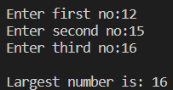

1. Check if the given number is Armstrong number or not.

**Code:**

num = int(input("Enter a number: "))

sum ,temp, p = 0,num,len(str(num))

while temp > 0:

digit = temp % 10

sum += digit ** p

temp //= 10

if num == sum:

print("\n",num,"is an Armstrong number\n")

else:

print("\n",num,"is not an Armstrong number\n")

**Output:**

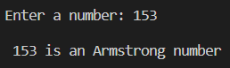

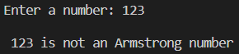

1. Write a program to demonstrate string data type

**Code:**

str , sub ,n = input("\nEnter a string:") , input("Enter a sub-string:"), int(input("Enter position:"))

str = str[:n] + sub + ' ' + str[n:]

print("\n",str)

**Output:**

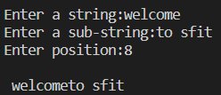

1. Write a Python program to count the occurrences of a word in a given sentence

**Code:**

sentence=str(input("Enter a sentence: "))

def word_count(str):

counts = dict()

words = str.split()

for word in words:

if word in counts:

counts[word] += 1

else:

counts[word] = 1

return counts

print( word_count(sentence))

**Output:**



1. Write a program to demonstrate list datatype

**Code:**

a = input("Enter 5 elements:")

l = list(map(int , a.split()))

print("List: ",l,"\nMax element:",max(l),"\nMin element:",min(l))

**Output:**

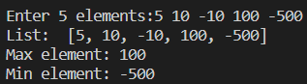

1. Write a program to demonstrate dictionary data type

**Code:**

countries=["India","Italy","Switzerland","France"]

cities=['Mumbai','Venice','Zurich','Paris']

z=zip(countries,cities)

d=dict(z)

print('{:10s}--{:10s}'.format('COUNTRY','CAPITAL'))

for k in d:

print('{:10s}--{:10s}'.format(k,d[k]))

**Output:**

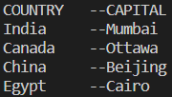

1. Write a program to demonstrate tuple data type

**Code:**

num=(1,34,36,43,70)

print(num)

lst=[int(input('Enter a new element: '))]

new=tuple(lst)

pos=int(input('Enter position no.: '))

num1=num[0:pos-1] + new + num[pos:]

print(num1)

**Output:**

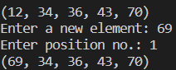

1. Write a program to demonstrate set data type

**Code:**

set1 = set()

print("Intial blank Set: ")

print(set1)

set1 = set("AIRBUS")

print("\nSet with the use of String: ")

print(set1)

String = 'BOEING'

set1 = set(String)

print("\nSet with the use of an Object: " )

print(set1)

set1 = set(["BOEING", "AND", "AIRBUS"])

print("\nSet with the use of List: ")

print(set1)

**Output:**

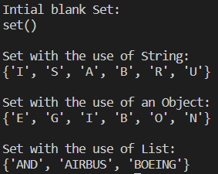

### CONCLUSION:

Successfully learnt to use various data types, and the various operations on it.